

Parallel & Distributed Computing

CSE525

Assignment **#1** - to be submitted to **Dr. Masroor Hussain**

**CUDA based C code for Matrix Addition & Multiplication**

Submitted by,

**Quswar Mahmood Abid, CS2003**

**CUDA Matrix Addition and Multiplication**

# Code kernels for matrix multiplication and addition

Attached files are cuda based C code for matrix multiplication and addition. Following shown are results for them. We see a matrix addition of two matrices of sizes 32x32, one with all filled with ‘0’ and the other with ‘1’. The answer is as follow:

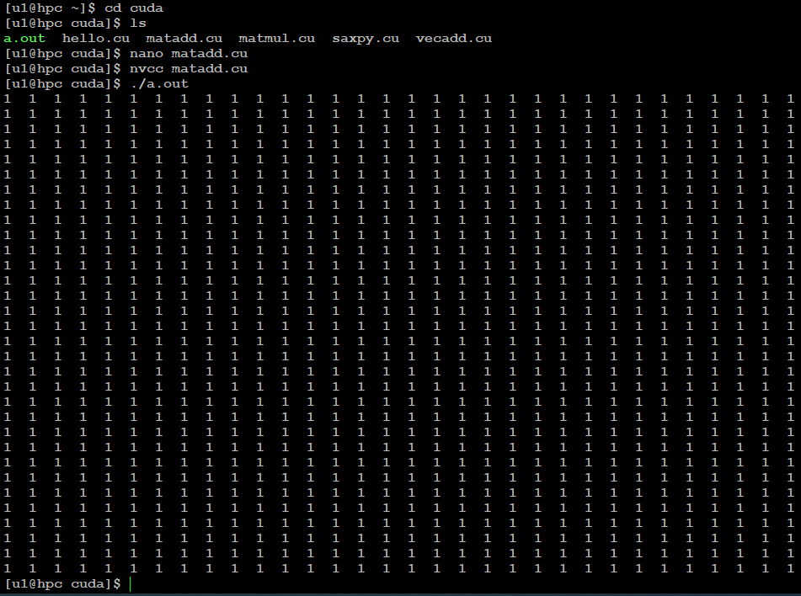

Figure . 32x32 sized matrices addition with all '1' filled in one, and all '0' filled in other

This one shows the multiplication of two matrices of sizes 16x16 with all ‘2’ filled in one and ‘1’ filled in other.

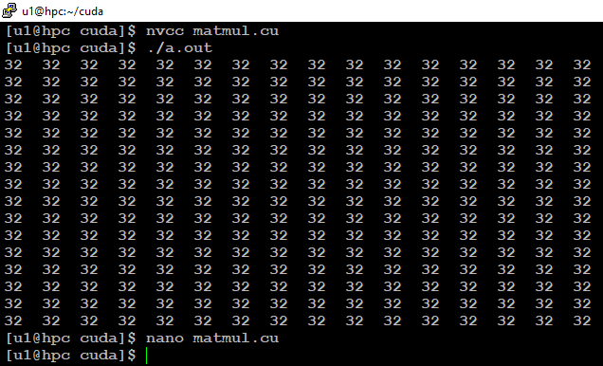

Figure . multiplication of two matrices of sizes 16x16 with all ‘2’ filled in one and ‘1’ filled in other